PRACTICAL – 8
ONLINE LEARNING MANAGEMENT SYSTEM
Moodle Demo – Test Scenarios

Student Name | Nikhil Chavda
Project Name | Online Learning Management System
Application/Software | Moodle Demo
Module Name | Course Management & Learning Activities
Test Plan | Online Learning Testing
Test Suite | Course & Quiz Testing
Test Case Description | Functional testing of course, learning activity and quiz features
Prerequisites | Moodle demo website is accessible
Environment | Google Chrome / Windows

TEST SCENARIOS
TC001 – Search for a course
Scenario ID: TC001
Scenario: Search for a course
Test Steps:
> Step 1: Open course page
> Step 2: enter course name
> Step 3: search
Test Input: Valid course name
Expected Result: Relevant course is displayed
Actual Result: Relevant course displayed
Status: Pass
Comments: Search works correctly
Screenshot:
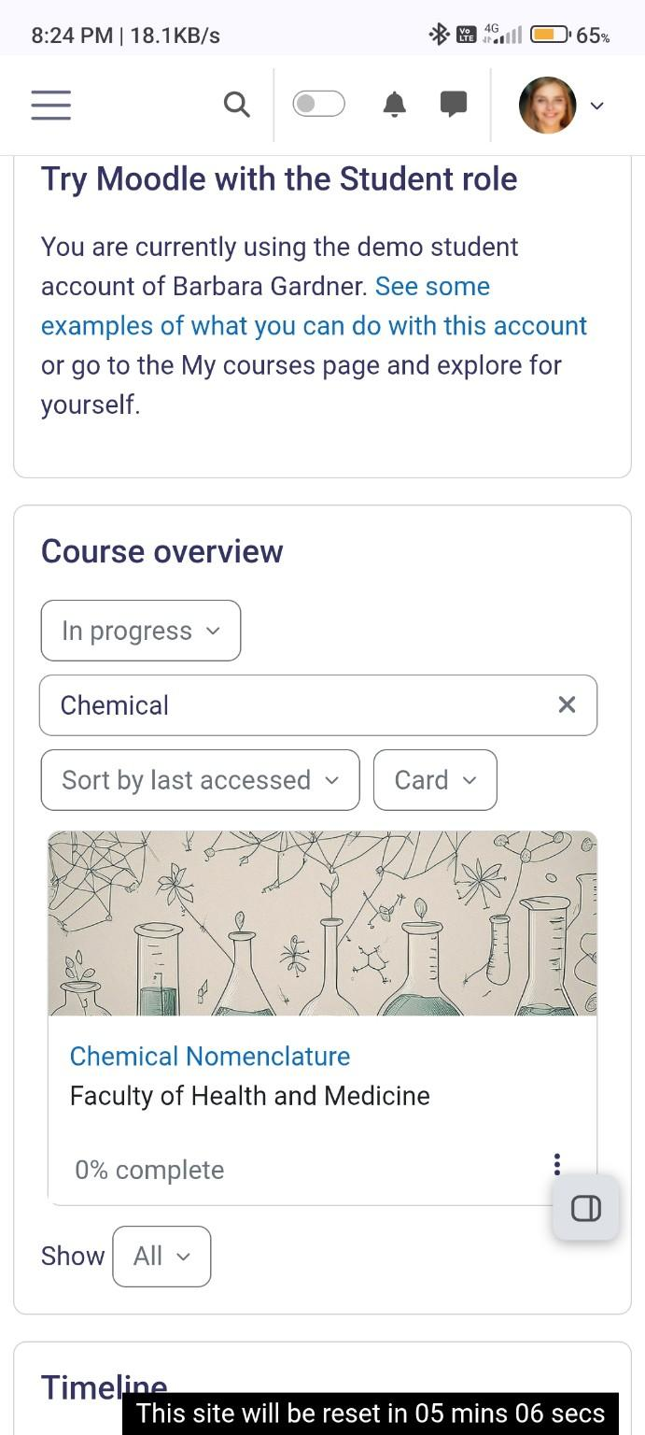
Figure: Moodle demonstration for TC001

TC002 – Open course details
Scenario ID: TC002
Scenario: Open course details
Test Steps:
> Step 1: Select a course
> Step 2: open course details
Test Input: Available course
Expected Result: Course details page opens
Actual Result: Course details opened
Status: Pass
Comments: No defect
Screenshot:
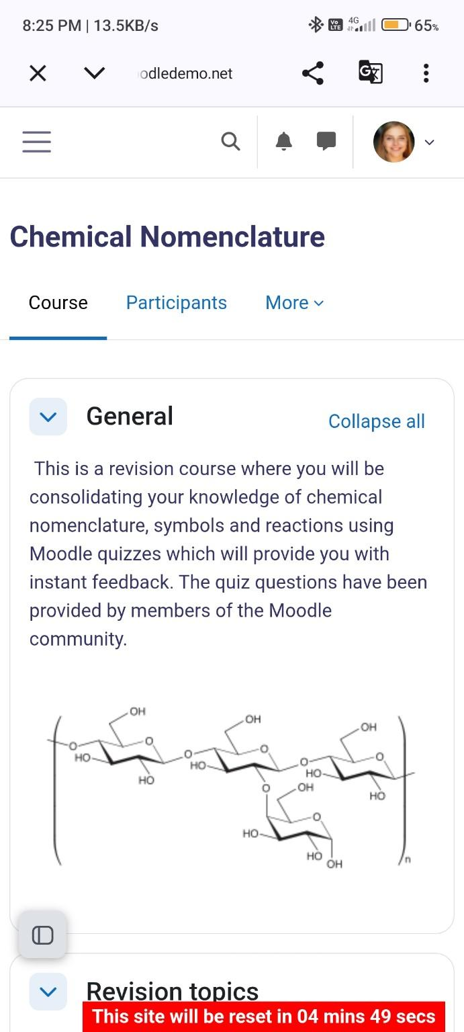
Figure: Moodle demonstration for TC002

TC003 – View course content
Scenario ID: TC003
Scenario: View course content
Test Steps:
> Step 1: Open course
> Step 2: select course content
Test Input: Available course
Expected Result: Course content is displayed
Actual Result: Course content displayed
Status: Pass
Comments: Content accessible
Screenshot:
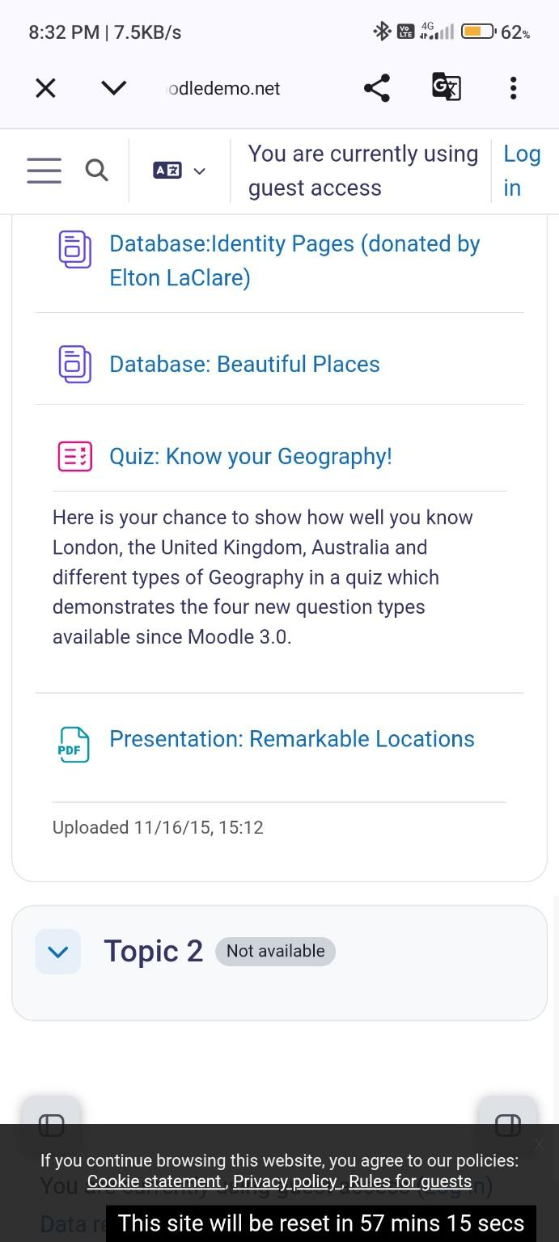
Figure: Moodle demonstration for TC003

TC004 – Open learning activity
Scenario ID: TC004
Scenario: Open learning activity
Test Steps:
> Step 1: Open course
> Step 2: select an activity
Test Input: Available activity
Expected Result: Selected activity opens
Actual Result: Selected activity opened
Status: Pass
Comments: Activity accessible
Screenshot:
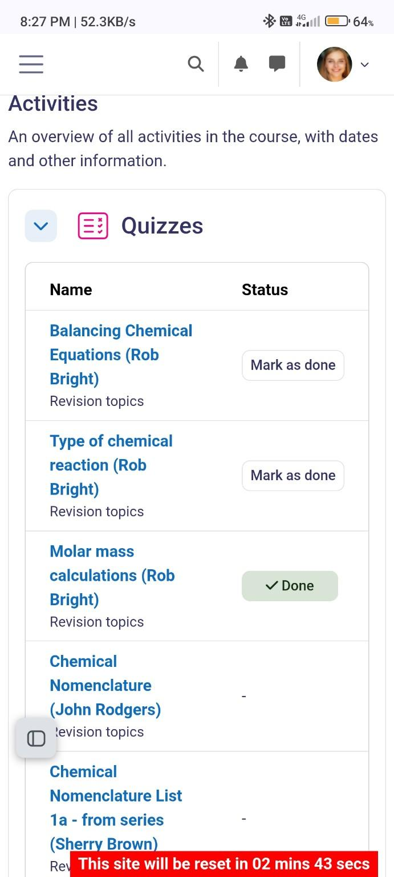
Figure: Moodle demonstration for TC004

TC005 – Start quiz
Scenario ID: TC005
Scenario: Start quiz
Test Steps:
> Step 1: Open course
> Step 2: select quiz
> Step 3: start quiz
Test Input: Available quiz
Expected Result: Quiz starts successfully
Actual Result: Quiz started successfully
Status: Pass
Comments: No defect
Screenshot:
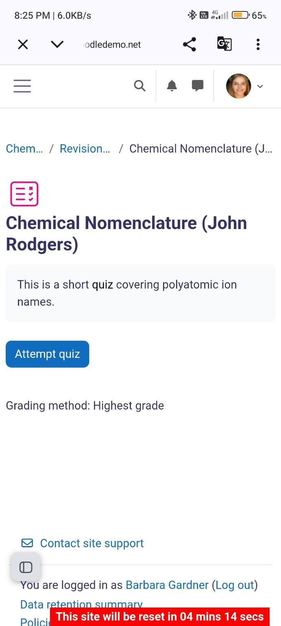
Figure: Moodle demonstration for TC005

TC006 – Submit quiz
Scenario ID: TC006
Scenario: Submit quiz
Test Steps:
> Step 1: Answer quiz
> Step 2: click submit
Test Input: Valid quiz answers
Expected Result: Quiz submission is accepted
Actual Result: Quiz submitted successfully
Status: Pass
Comments: Submission accepted
Screenshot:
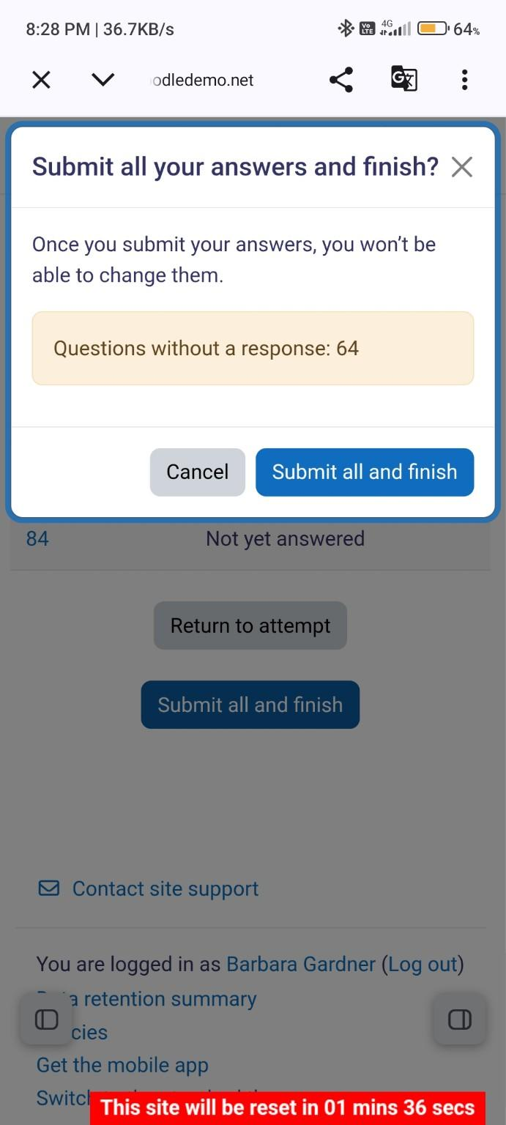
Figure: Moodle demonstration for TC006

TC007 – View quiz result
Scenario ID: TC007
Scenario: View quiz result
Test Steps:
> Step 1: Complete quiz
> Step 2: open result
Test Input: Completed quiz
Expected Result: Quiz result is displayed
Actual Result: Quiz result displayed
Status: Pass
Comments: Result visible
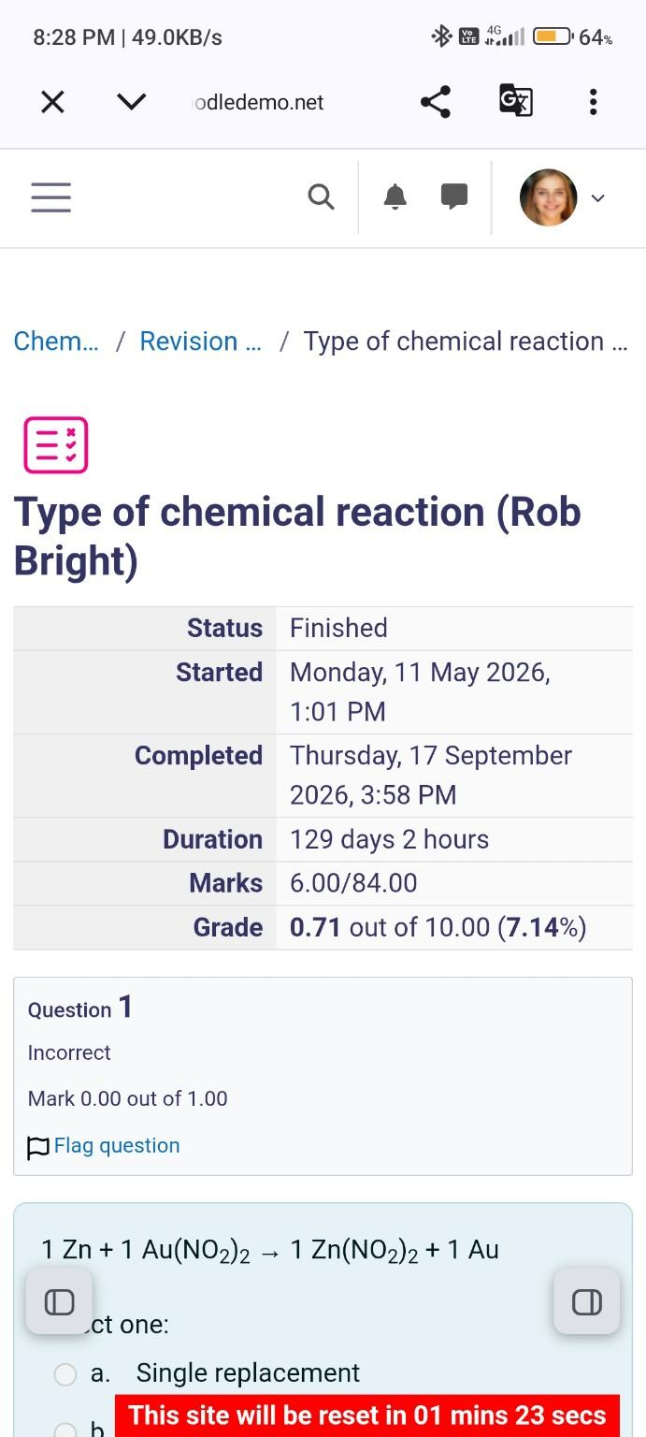
Figure: Moodle demonstration for TC007

TC008 – Access course material
Scenario ID: TC008
Scenario: Access course material
Test Steps:
> Step 1: Open course
> Step 2: select learning material
Test Input: Course material
Expected Result: Material opens/downloads correctly
Actual Result: Material opened correctly
Status: Pass
Comments: No defect
Screenshot:
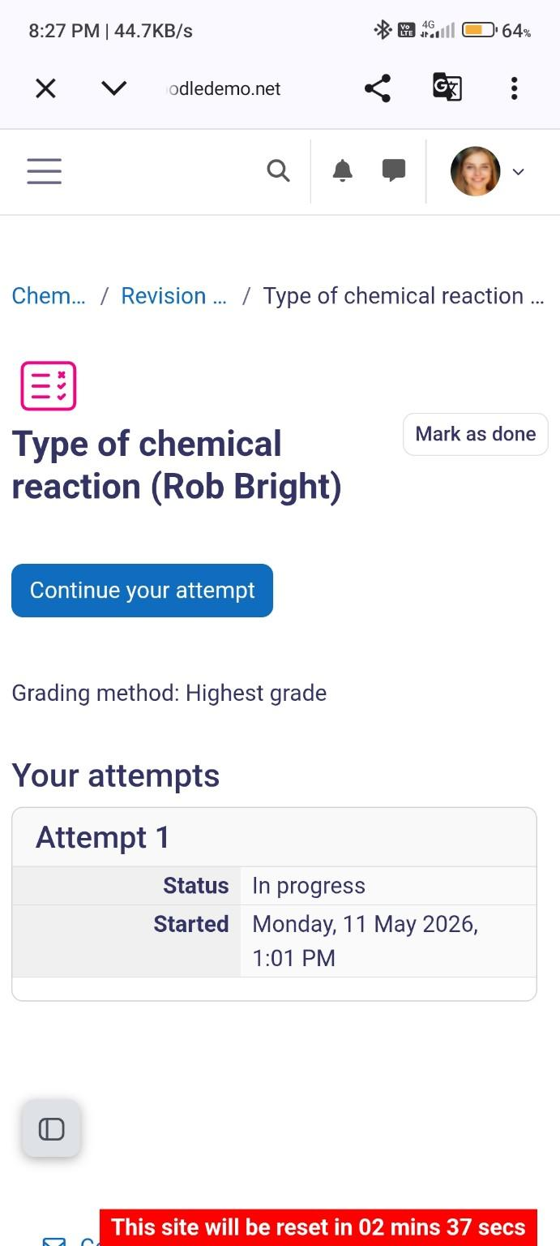
Figure: Moodle demonstration for TC008

TC009 – Navigate course sections
Scenario ID: TC009
Scenario: Navigate course sections
Test Steps:
> Step 1: Open course
> Step 2: move between sections
Test Input: Course sections
Expected Result: Correct section opens
Actual Result: Correct sections opened
Status: Pass
Comments: Navigation works
Screenshot:
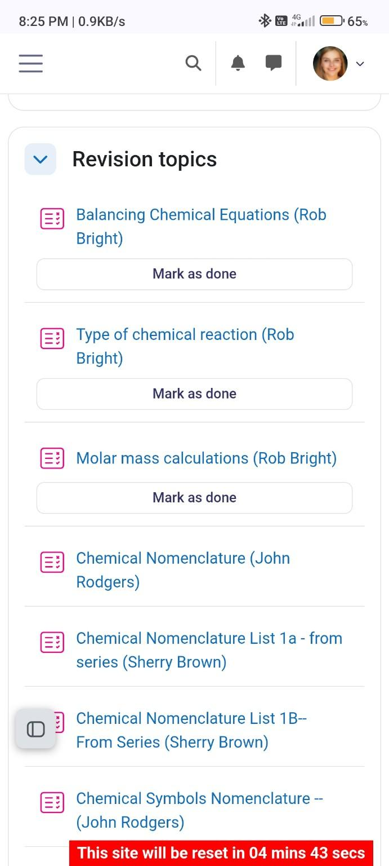
Figure: Moodle demonstration for TC009

TC010 – Search unavailable course
Scenario ID: TC010
Scenario: Search unavailable course
Test Steps:
> Step 1: Search
> Step 2: enter unavailable course name
Test Input: Invalid/unavailable course
Expected Result: No-result message is displayed
Actual Result: No-result message displayed
Status: Pass
Comments: Validation works
Screenshot:
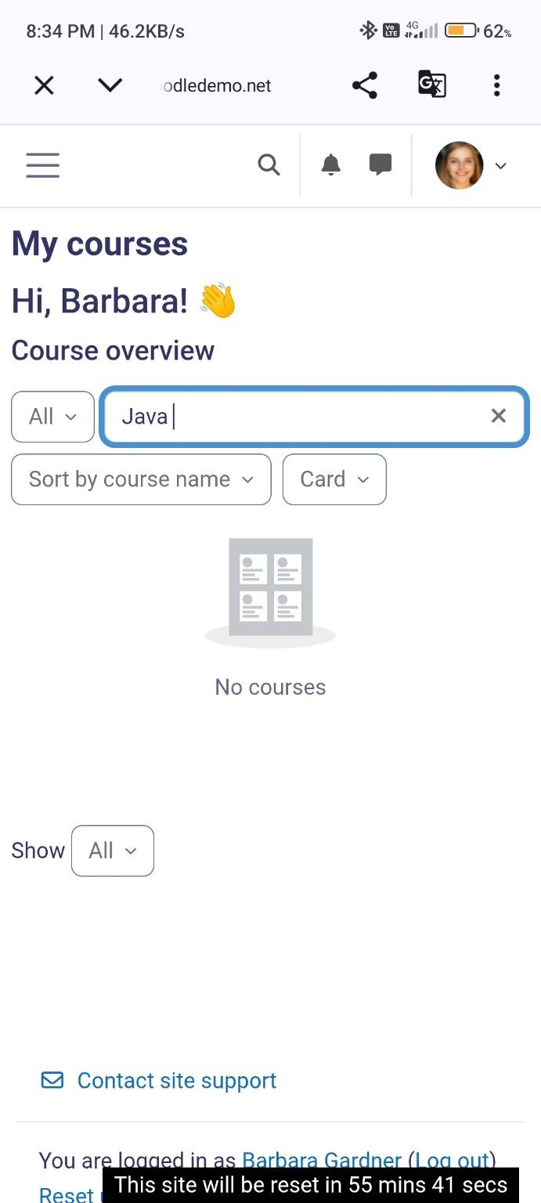
Figure: Moodle demonstration for TC010

